Creating ER Diagram in MySQL Workbench

1.After opening MySQL workbench , we can see a window like below,
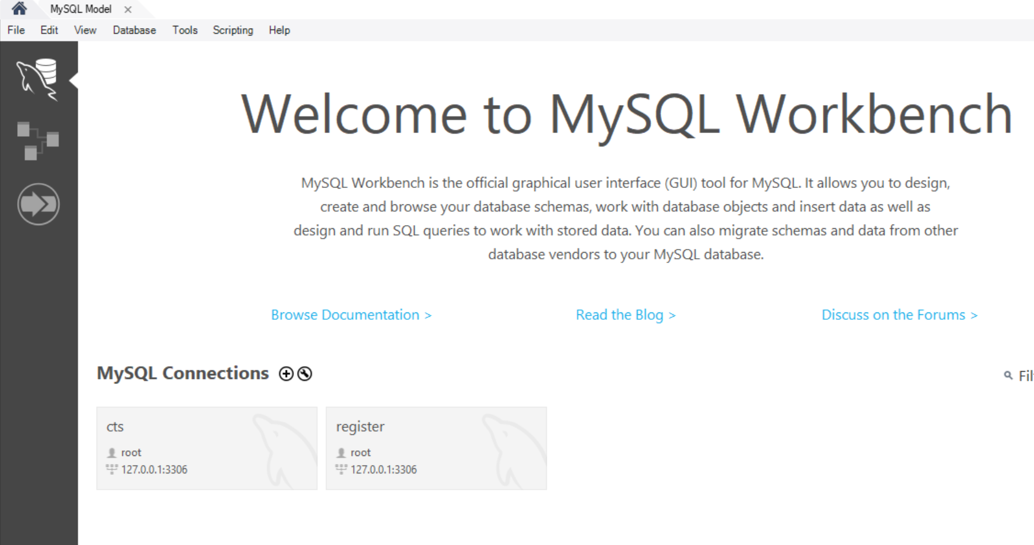

In the left top end we can see file menu just click on that, after clicking file menu it will display some options in that select “New Model”.
2. After clicking New Model we can see the below window,
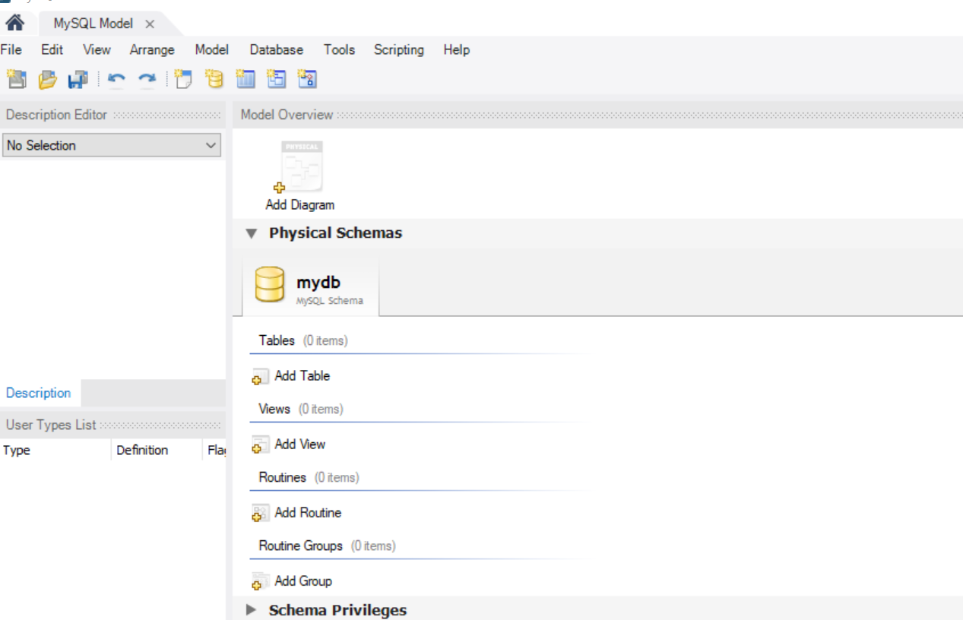
In Model Overview we can see Add diagram ,Just double click on Add Diagram
We can see the window like below,
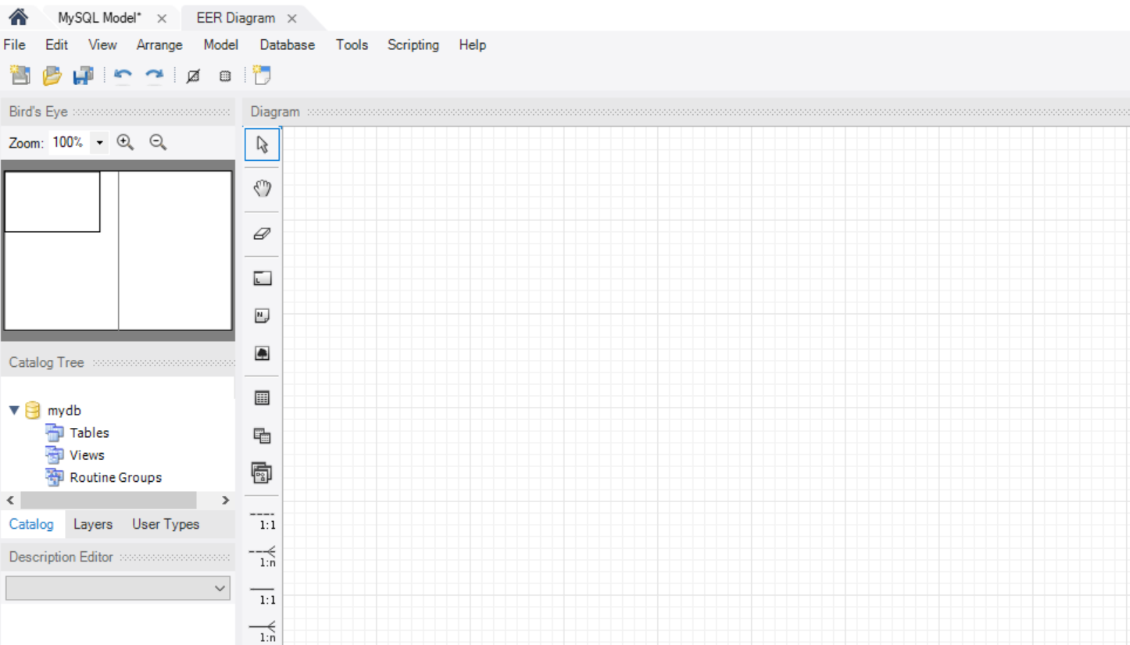

In Diagram we can see some symbols like table, relation symbols like 1:1,1:n etc, Just click on the table which is highlighted in the below image and after selecting the symbol now place the mouse cursor in the our working window
which is at right side in the below image (white window).
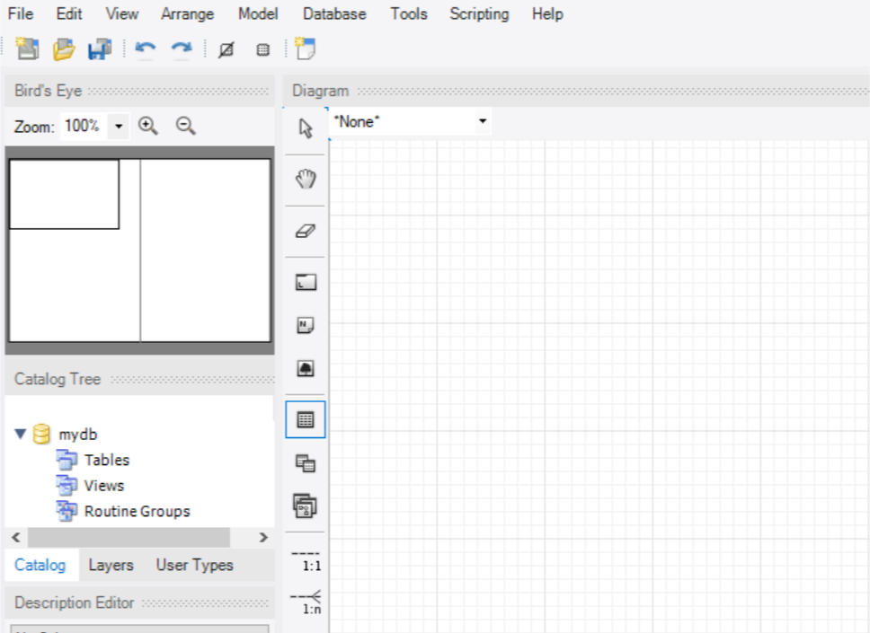

After performing the above operations then we can see the table as shown below,
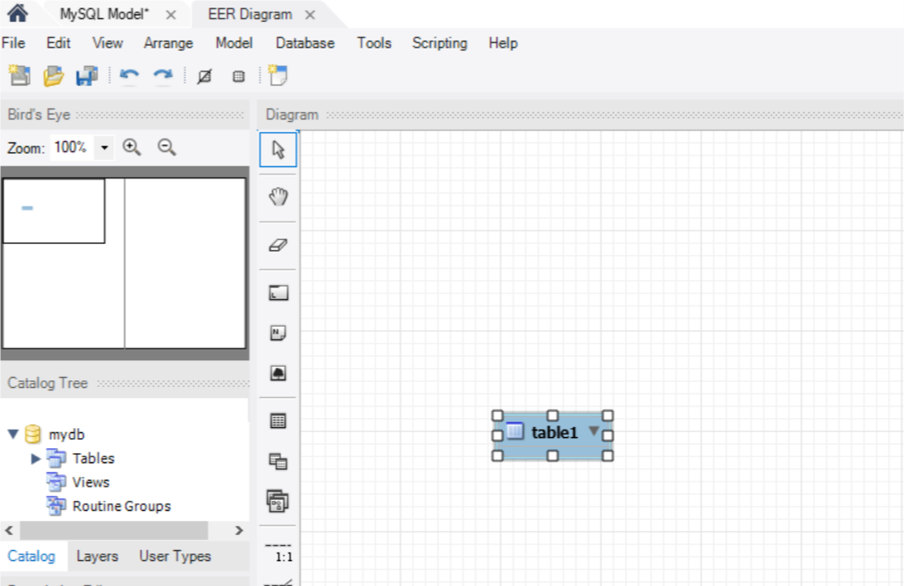

After double clicking on table we can able to edit the table name, column name and datatypes, which is shown in below image,
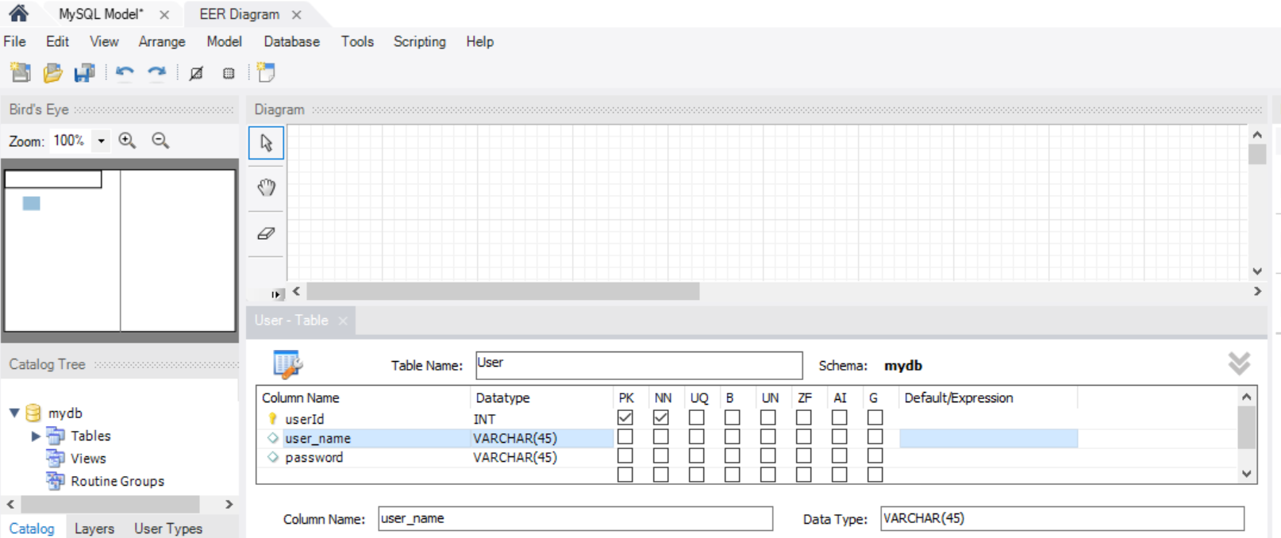

After providing column names, datatype just close the tab
In the below image User-table is one of the tab just close that tab.
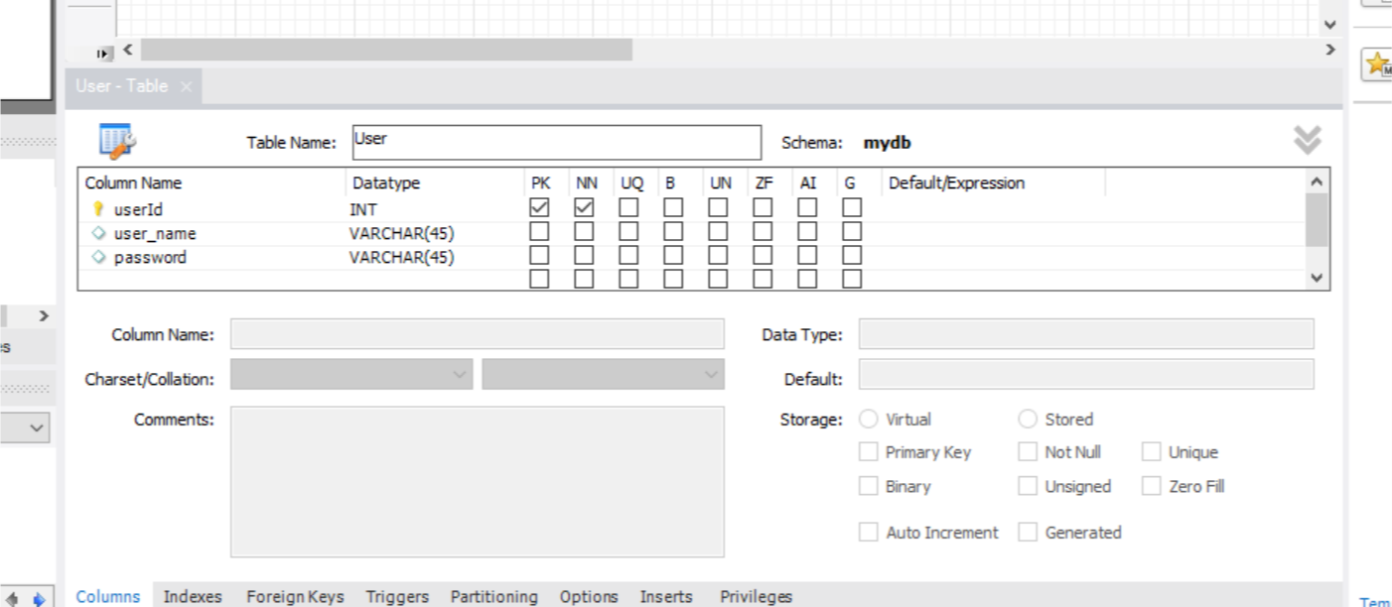

After closing the tab then we can able to view the table which we created which is shown in below image,
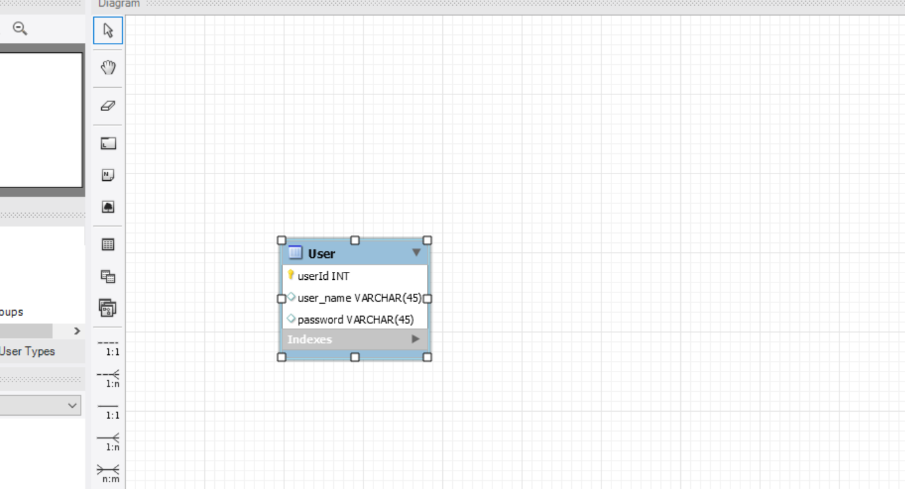

Similarly we can create as many tables as we want and we can provide relationships to by using the symbols from one table to another table
Which is shown in the below image.

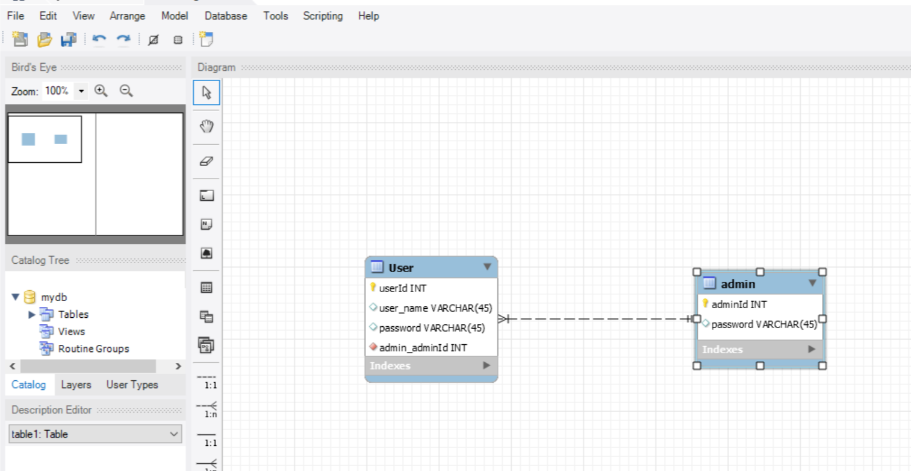

After Completing ER Diagram then we can find a export option in the file menu
At the left side top end. Export the diagram in your local directory.

